Tutorial 4 – Character Strings
- (processString) Write a C function that accepts a string str and returns the total number of vowels totVowels and digits totDigits in that string to the caller via call by reference. The function prototype is given as follows:

void processString(char *str, int *totVowels, int *totDigits); A sample program template is given below to test the function:
#include <stdio.h> #include <string.h>
void processString(char *str, int *totVowels, int *totDigits); int main()
{
char str[50], *p;
int totVowels, totDigits;

printf("Enter the string: \n"); fgets(str, 50, stdin);
if (p=strchr(str,'\n')) *p = '\0'; processString(str, &totVowels, &totDigits); printf("Total vowels = %d\n", totVowels); printf("Total digits = %d\n", totDigits); return 0;
}
void processString(char *str, int *totVowels, int *totDigits)
{

/* Write your code here */
}

Some test input and output sessions are given below:

  - Test Case 1: Enter the string:
I am one of the 400 students in this class. Total vowels = 11
Total digits = 3

  - Test Case 2: Enter the string: I am a boy. Total vowels = 4 Total digits = 0

  - Test Case 3: Enter the string: 1 2 3 4 5 6 7 8 9

Total vowels = 0 Total digits = 9

  - Test Case 4: Enter the string:
ABCDE
Total vowels = 2 Total digits = 0
- (stringncpy) Write a C function stringncpy() that copies not more than n characters (characters that follow a null character are not copied) from the array pointed to by s2 to the array pointed to by s1. If the array pointed to by s2 is a string shorter than n characters, null characters are appended to the copy in the array pointed to by s1, until n characters in all have been written. The stringncpy() returns the value of s1. The function prototype is given below:

char *stringncpy(char *s1, char *s2, int n);
A sample program template is given below to test the function: #include <stdio.h>
#include <string.h>
char *stringncpy(char *s1, char *s2, int n); int main()
{
char targetStr[40], sourceStr[40], *target, *p; int length;

printf("Enter the string: \n"); fgets(sourceStr, 40, stdin);
if (p=strchr(sourceStr,'\n')) *p = '\0'; printf("Enter the number of characters: \n"); scanf("%d", &length);
target = stringncpy(targetStr, sourceStr, length); printf("stringncpy(): %s\n", target);
return 0;
}
char *stringncpy(char *s1, char *s2, int n)
{

/* Write your code here */
}

Some sample input and output sessions are given below:
  - Test Case 1: Enter the string:

I am a boy.
Enter the number of characters:
7
stringncpy(): I am a

  - Test Case 2: Enter the string:
I am a boy.
Enter the number of characters:
21
stringncpy(): I am a boy.

  - Test Case 3: Enter the string:
somebody
Enter the number of characters:
7
stringncpy(): somebod

  - Test Case 4: Enter the string:
somebody
Enter the number of characters:
21
stringncpy(): somebody

- (stringcmp) Write a C function that compares the string pointed to by s1 to the string pointed to by s2. If the string pointed to by s1 is greater than, equal to, or less than the string pointed to by s2, then it returns 1, 0 or –1 respectively. Write the code for the function without using any of the standard C string library functions. The function prototype is given as follows:
int stringcmp(char *s1, char *s2);
A sample template for the program is given below: #include <stdio.h>
#include <string.h> #define INIT_VALUE 999
int stringcmp(char *s1, char *s2); int main()
{
char source[80], target[80], *p; int result = INIT_VALUE;

printf("Enter a source string: \n"); fgets(source, 80, stdin);
if (p=strchr(source,'\n')) *p = '\0';

printf("Enter a target string: \n"); fgets(target, 80, stdin);
if (p=strchr(target,'\n')) *p = '\0'; result = stringcmp(source, target); if (result == 1)
printf("stringcmp(): greater than"); else if (result == 0)
printf("stringcmp(): equal"); else if (result == -1)
printf("stringcmp(): less than"); else
printf("stringcmp(): error"); return 0;
}
int stringcmp(char *s1, char *s2)
{

/* Write your code here */
}

Some test input and output sessions are given below:

  - Test Case 1:
Enter a source string: abc
Enter a target string: abc
stringcmp(): equal

  - Test Case 2:
Enter a source string: abcdefg
Enter a target string: abcde123
stringcmp(): greater than
  - Test Case 3:
Enter a source string: abc123
Enter a target string: abcdef
stringcmp(): less than

  - Test Case 4:
Enter a source string: abcdef
Enter a target string: abcdefg
stringcmp(): less than

- What does the following program print?
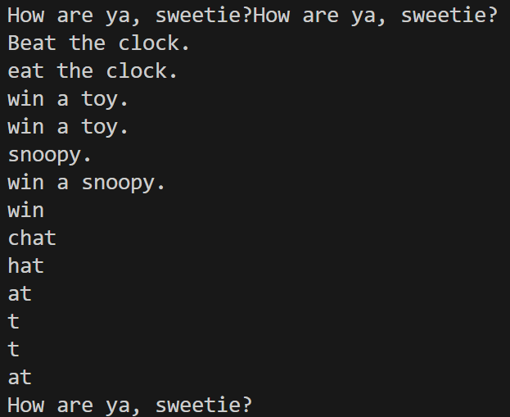
#include <stdio.h> #include <string.h>
#define M1 "How are ya, sweetie?" char M2[40] = "Beat the clock."; char *M3 = "chat";
int main()
{
char words[80],*p; printf(M1); puts(M1);
puts(M2); puts(M2+1);
fgets(words, 80, stdin); /* user inputs : win a toy. */ if (p=strchr(words,'\n')) *p = '\0';
puts(words);
scanf("%s", words+6); puts(words);
words[3] = '\0'; puts(words);
/* user inputs :
snoopy. */
while (*M3) puts(M3++); puts(--M3);
puts(--M3); M3 = M1;
puts(M3); return 0;
}

